Site Administration - Day to Day (Subs, Orders, Invoices)

The ‘Day to Day’ button’s menu selections are illustrated below.

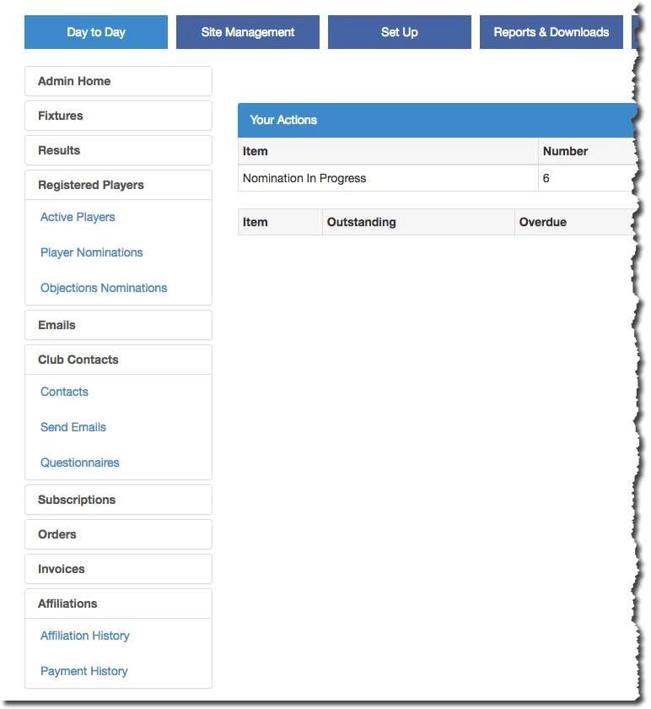

Subscriptions, Orders & Invoices
These functions allow a league administrator to issue invoices to affiliated clubs for subscriptions plus other items such as course fees, cricket balls and handbooks.

There is a topic in the Help Guides titled ‘Subscriptions, Orders & Invoices’ which deals with these sections.

