Play-Cricket Player Registrations – GDPR
We’ve applied various GDPR Principles to Play-Cricket registration processes, the implications are documented below:
- Privacy by design, you will now only see the data that you need to see.
- Players will be notified when their data is being used
- All players registered on Play-Cricket.com will receive a Privacy Notice
- Everyone has a right to be deleted from Play-Cricket.com
  - First and second name will always remain on the scorecard.
- Established a clear difference between marketing Consent and Legitimate day to day use of data.
- Parental consent and account ownership for all u16 players.
- Tightened marketing and communication consents within Play-Cricket.com

Club and League Privacy Notices
The two relationships in question are between the player / parent and their Club, and Club and League not between the player and Play-Cricket.
By Law, all Clubs and Leagues are required to have a privacy notice. Play-Cricket will help by providing generic privacy notices for all Play-Cricket registered Clubs and Leagues ensuring everyone is covered (clubs can additionally add to this if they wish or need to).
The benefit of doing this is to ensure that everyone using Play-Cricket can be GDPR compliant.

ECB Data Hygiene principles
ECB have adopted the following principles to keep the data held by Play-Cricket.com clean and relevant:
- First name, surname and club will never be deleted from scorecards
  - The ability to search historically is required for child welfare compliance.
- After two years of inactivity all data (other than the above) will be deleted.
- Individuals can only see the data they NEED to see to perform their role.
- Data can be updated by data controllers - either the individual and club. Players will be notified of all changes.
- Selected data will be shared for business to occur.

Player Sign-up Process
A player can still apply online to join any club, but the player will now be central to the process of both sign up and transfer.
The player will be issued with a Privacy Notice when their membership is actioned, and they will then decide whether to become a registered Play-Cricket user or not. A club with data gathered from the player can initiate the sign-up process and the player will be informed – a player can say NO at this stage.

Adding a new Club member on Play-Cricket.com
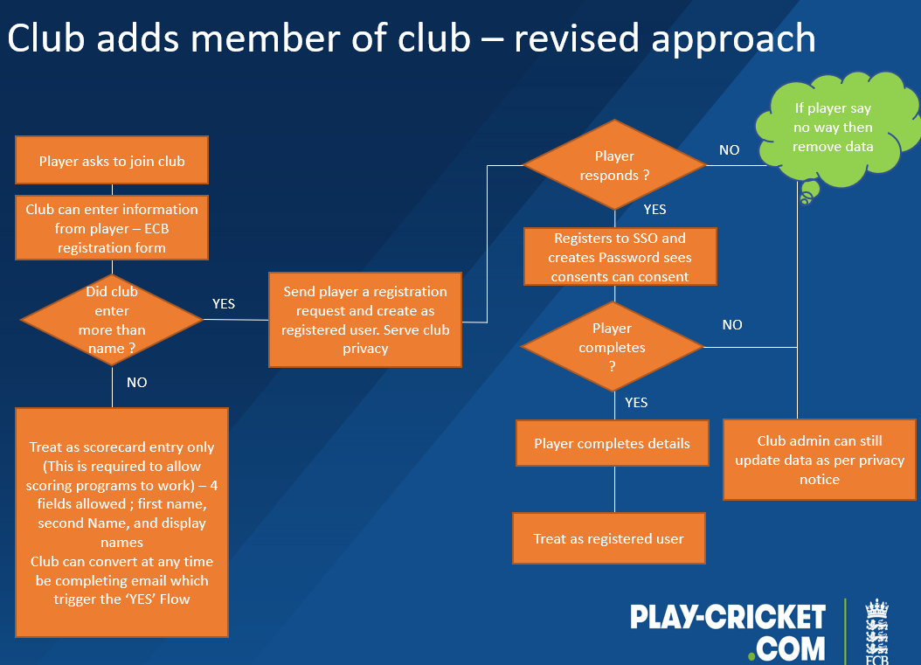
This new process means:
- Club members are informed at all stages of Play-Cricket registration process
- The player/club must agree to share their data on Play-Cricket.com
- A parent must consent to their child’s details being added to the site
- An alternative display name is now available allowing you to identify players with the same name e.g. John Smith and John Smith (Snr)

Visibility on Play-Cricket.com
There are three ways that a person may be visible on Play-Cricket.com
- A name on a scorecard
- As a full member of a Club
- As a member of a Club and registered to a League (the Club must consent to sharing this data)
*At stage 2 and 3 the individual can consent to receive ECB marketing information.
In instances 2 and 3 chart 9 (above) there is legitimate business need for ECB, CCB, Club and League to see the data, allowing the Club, CCB and ECB communicate excluding marking promotions to people as a legitimate business need.

The difference between a scorecard entry and the other categories is that the person has been served a privacy notice and can receive communications if they have opted-in to receive comms.
*For U16’s it’s the parent that will receive all communications, not the child.

Transferring Players Diagram
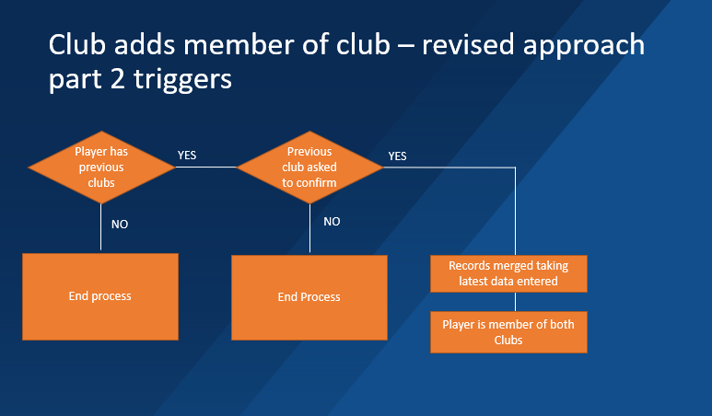

A player or ‘owner club’ must agree to share the players data to confirm the transfer of the player between clubs. The new club must request the information held by the players old club to be shared.

ECB will assist Club and League GDPR compliance by:
- Implementing a full membership form so that Clubs will not need additional systems.
- When added to Play-Cricket.com a Club member (player or official) will be served a default ECB GDPR compliant privacy notice (clubs can add additional sections).
- The member is automatically assigned a userID which, when validated, can be used to complete registration/login.
Additional registration set up details
- If a Club has served a Privacy Notice to a player but they do not complete registration, the club can still edit the data. As a privacy notice has been served to the player.
- For U16 players, the parent account not the u16 player owns the userID. The parent MUST register, or the child data is removed until this happens. A parent needs to explicitly consent to u16 player data being edited or shared.

Clubs registering a player to a League
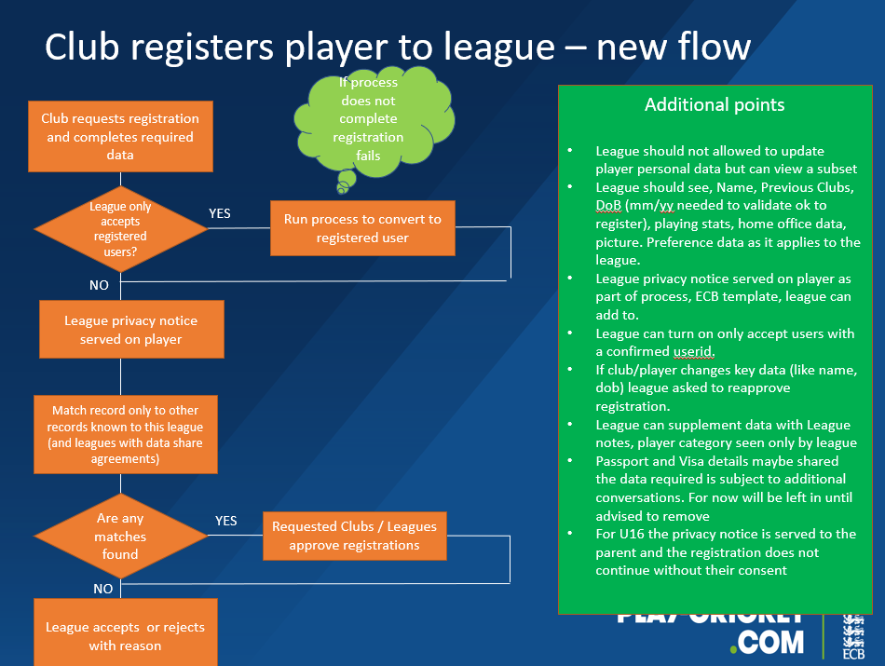
As a club admin you cannot see any player data across the site, you’re now limited to being able to player match to those only in your region or league structure – instead of a site wide player search. Leagues will be able to see selected player data but cannot amend this.
A parent of an U16 player will need to consent for the players data to be shared. The club must agree that the player can be registered with the League and the parent must confirm this transaction.

Selecting administrator roles
There is added flexibility for clubs regarding which of their administrators can access the data. Clubs can also create and define the level of data access per role. We already have multiple admin roles defined as shown in chart 17.
Clubs can define their own roles, for example someone could now act as both fixtures’ admin and News admin and not see membership data. There is no need to have ‘main admin’ rights to perform more than one role now there is the ability to select the roles an individual performs

Headline overview

- You MUST stop doing administration on paper (or at least be aware of the risks – data must be kept secure)
- Read the ECB guidance notes; on GDPR: https://www.ecb.co.uk/news/672545. If you feel the need, please take further GDPR advice.
- Use the Play-Cricket System and encourage others too as it deploys GPDR privacy notices and stores data securely.
- Encourage players to register on Play-Cricket.com and consent to receive Player Comms, players who receive these are less likely to lapse from playing and play more often (source: ECB player survey)
- Don’t forget that you can add to ECBs default Privacy Notice. (You may be part of a larger organisation and need to share your membership data for legitimate reasons with them).

