The League Registration process

Introduction

The player registration process
- Removes duplicates from the system.
- Improves transfer management giving leagues and clubs chances to approve and object.
- Includes a cross league transfer process.

This reduces the load on administrators by providing all the information in one place and improve the quality of the playing data for the clubs, leagues and players by combining one of more instances of the same person.

In the past player registration has been very much league by league and club by club. When a club submitted a registration to a league checks were made regarding the player’s history, and duplications were highlighted to allow clubs and leagues the ability to resolve players being registered twice for different clubs at different times. These checks relied on processes outside the workflow and led to many time-consuming issues for league, clubs and players.
- It was very easy to have a player registered for 2 clubs simultaneously in the same league.
- It was difficult to resolve a player registering in different leagues for different clubs.
- The processes to gain approval from club to transfers were outside of the workflow and often paper based.
- The result at the end of a transfer was often a new (duplicate) record for the player and a fragmentation of his playing stats.

The changes to the process improve the transparency of who is applying to which club in which league by providing within the workflow, communications to interested parties who can raise approval or objections to a registration. This will save league and club administrators’ time and effort in chasing transfers between clubs and often between clubs in differing leagues.
Each interested party is prompted in workflow items on the Admin Home page when action is needed.
The system recognizes many duplicate players based on surname plus date of birth. If any of those records have live league registrations, transfer requests are raised. The process then allows the league administrators to merge the playing records so that at the end of the process a single player record exists with all roles and playing stats attached rom all previous clubs.

- For a simple new registration of a player for the first time there is no change to the process.
- To conform with GDPR legislation, clubs no longer include proposed matches on the nomination. When the league processes the nomination, the system will identify proposed matches from players already / previously registered with that league and also other leagues which have a data sharing agreement.
- Objections and approvals are built in the workflow and the merge of the old and new records happens on a button press from the league when they accept the registration.
- For complex transfers across leagues a similar process is followed which each interested party being informed and having the ability to act.

The process is designed to fit with the operation of all leagues and so does not mandate that approvals must be given before registrations can be completed.
It is possible for a league administrator of the old league to allow both registrations to stay in place.
It is also possible to register a player for two different clubs in the same league as all these possible scenarios exist somewhere within cricket.

Getting started

When a club administrator nominates a player for registration to your league, he will be presented with a list of questions from the league to be answered for each player. Check that the questions that have been defined for standard nominations and transfers are suitable for your league.

To do this, go to Administration>Set Up>Registered Players>Define Process.

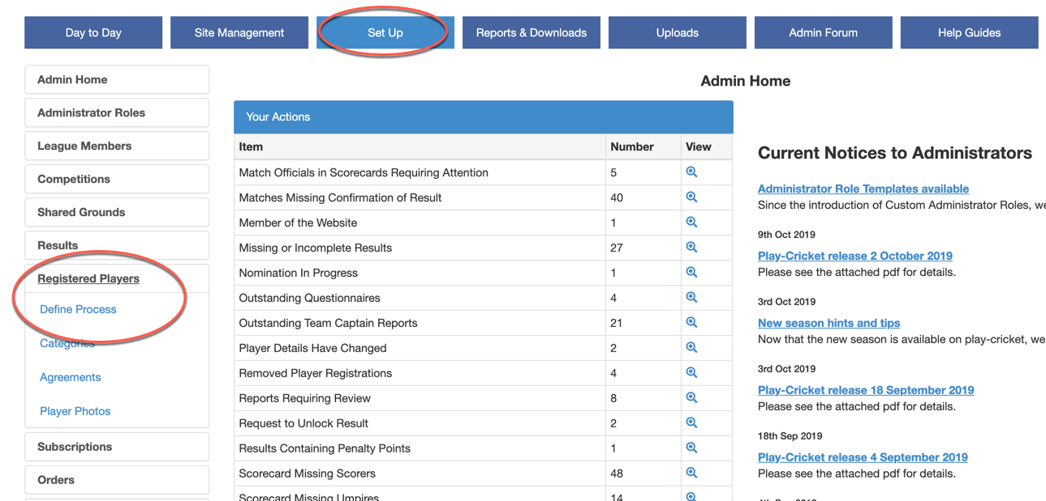
Here is the default Define Registration screen:

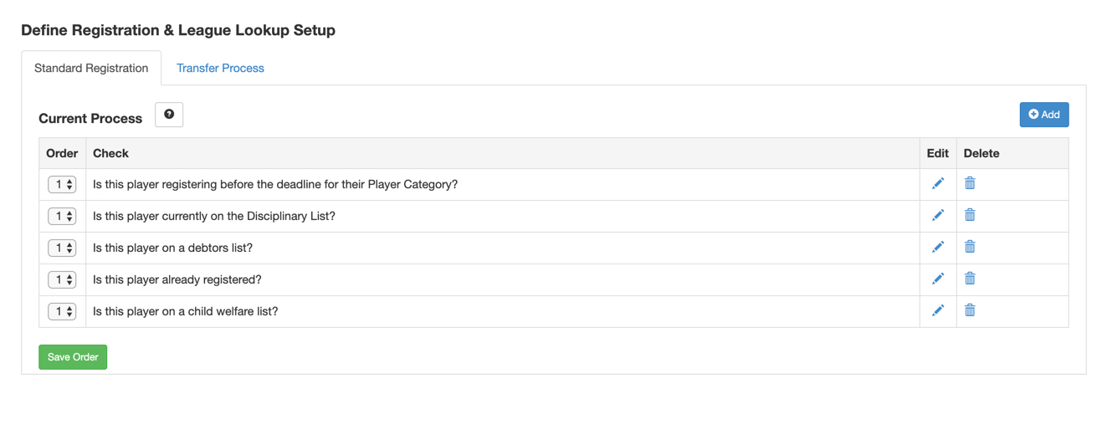

Using the Standard Registration and Transfer Process tabs, you can remove questions that are not required, and add more that are relevant to your league via the Add button.
Change the order of the questions using the boxes on the left-hand side and click the Save Order button.

It is also possible to enter a series of statements that a club administrator may agree to by ticking one check box rather than several as in the example below.

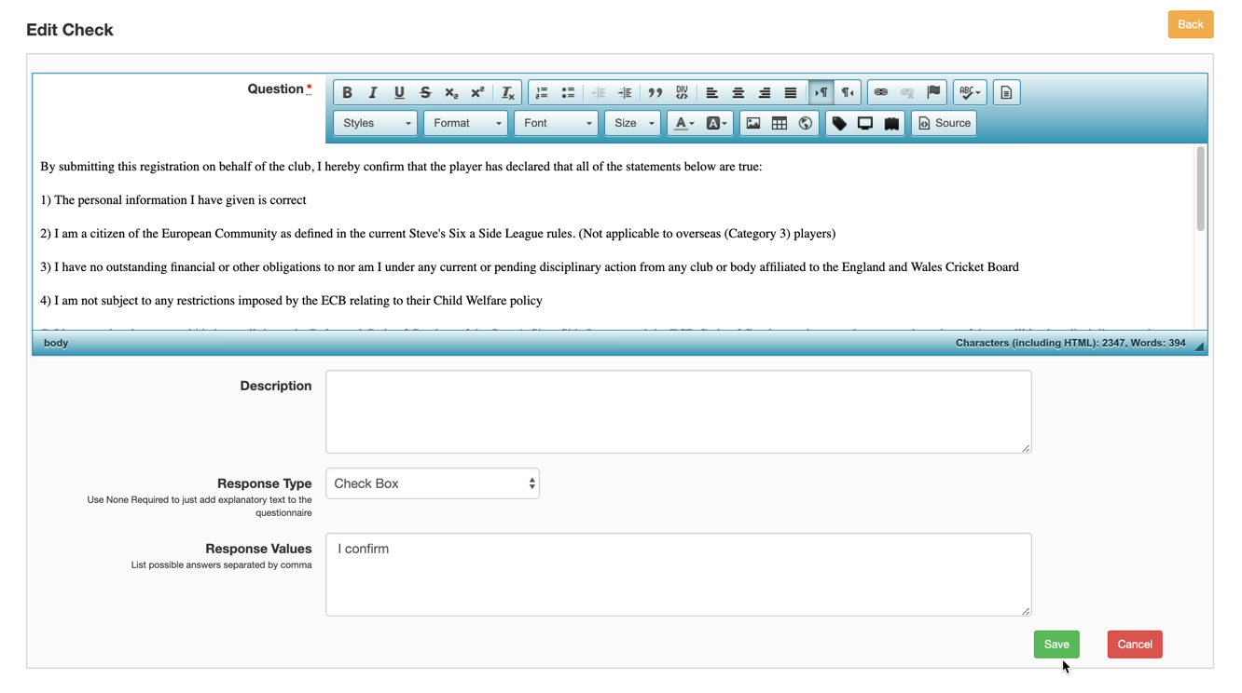

Switching on Player Registration

To operate league registration, a division must be set up with the Player Registration Required tick box checked as per the screen shot below.

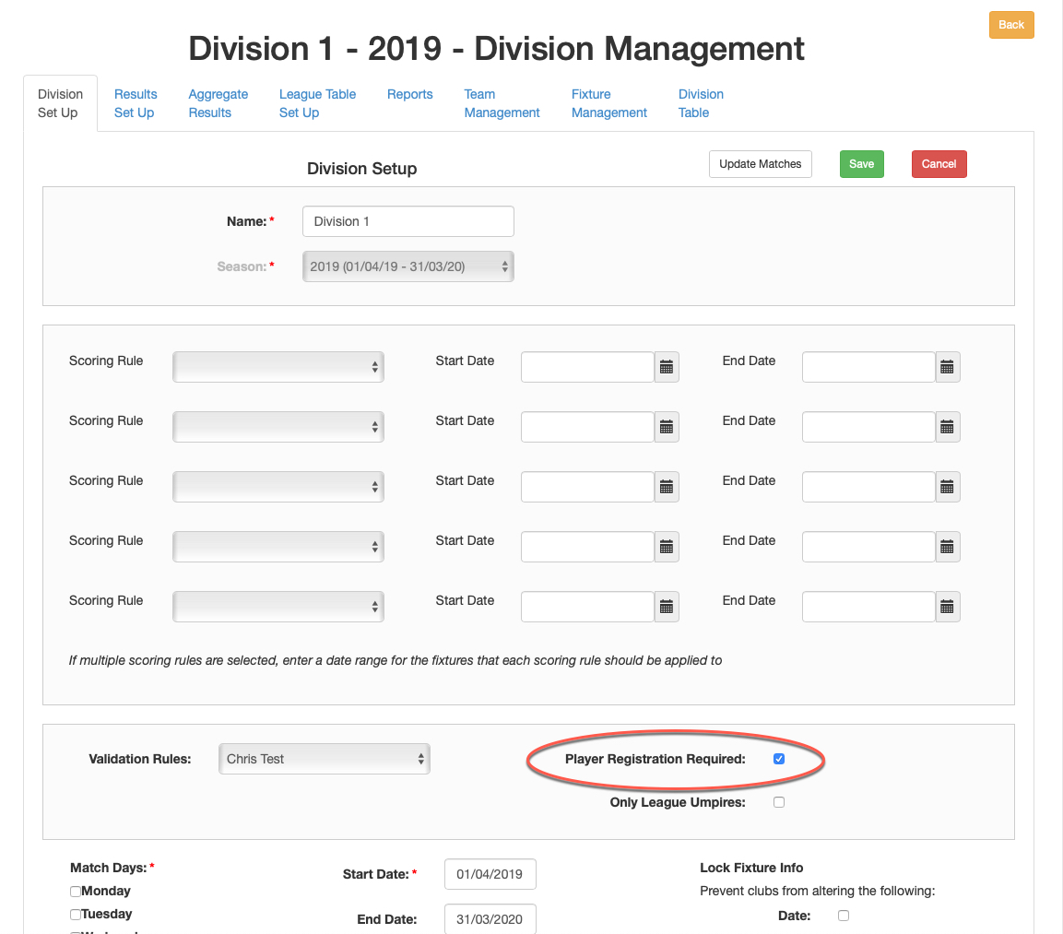

If the box is not ticked, clubs playing in that division will be unable to apply for registration to your league.

The nominations process

When a club has applied for league registration of a player, a notification will appear as a pending item on the Admin home page.

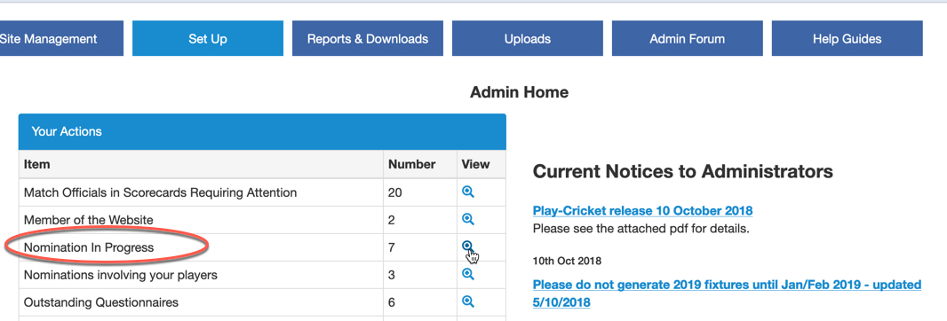

Select view to see a list of the pending nominations as below.

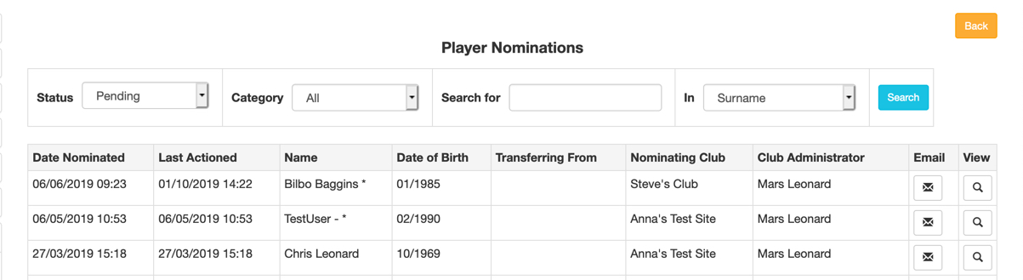

This is a simple registration where a player has joined a club and registers with a league:

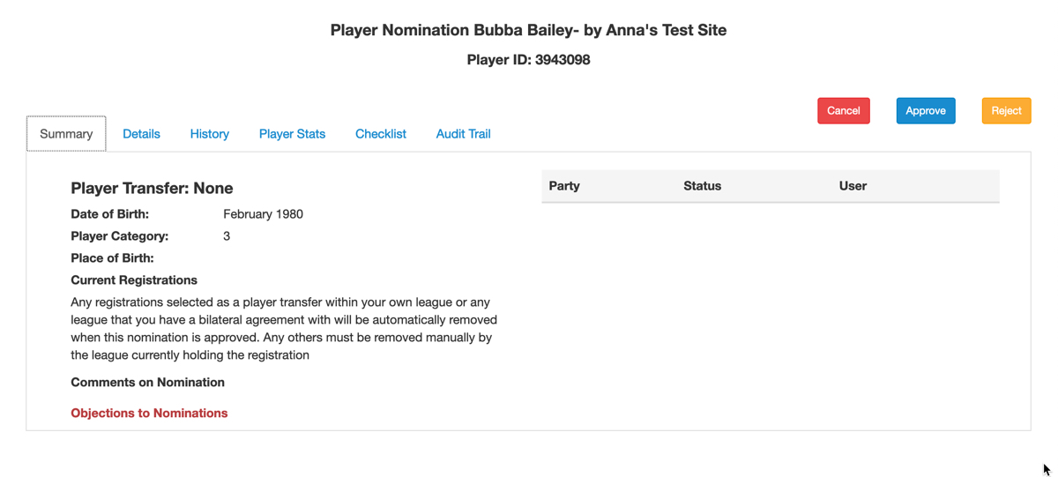
In example above, the player is not registered with another league, and is not a member of another club.

Details tab – shows a restricted view of player’s personal details. League administrators may no longer edit any fields in a player’s record.

History tab – shows a player’s league registration history.

Checklist – displays the questionnaire set by the league and completed by the club administrator. If any changes are made to the answers, click Save to update the form. The nomination remains as pending.

Player Stats – displays the playing history for the nominated player.

Audit Trail – shows the details of who made the nomination.

Cancel button – returns the user to the Pending Nominations screen and any unsaved changes are lost.

Approve button – use this to approve the nomination.

Reject button – click to reject the nomination and supply a reason for the rejection.

Matching records to remove duplication

Here is an example of a nomination showing a player where the system has identified one or more duplicate records that may be matched.

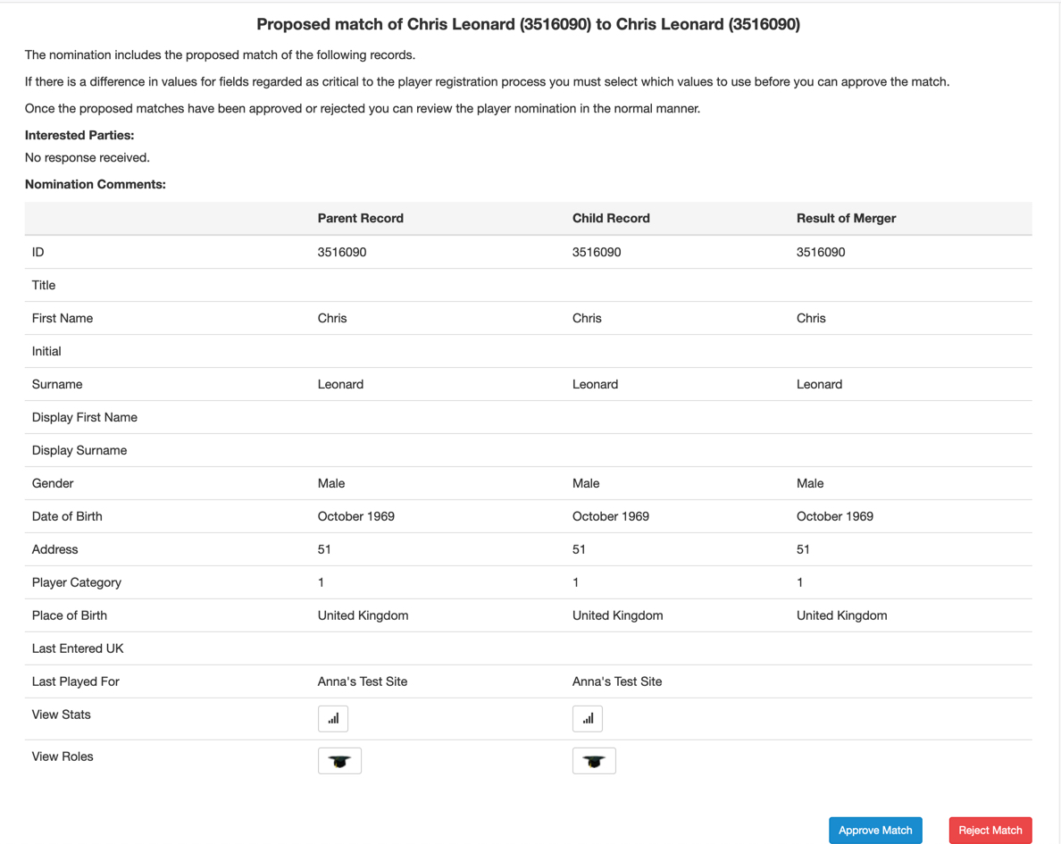

When a nomination involving a match of player records is viewed, the first screen to appear will be a match records dialogue. If there is more than one record to match, they will be displayed in turn.
Where differences are found, e.g. in the spelling of the first name or a different address, click on the radio button next to the required to value to select the result.
Beware – if the dates of birth and surnames are the same, but the first names are different, you may be looking at twins – check with the club administrator before action!

Note: Accepting a match and resolving the duplicate does not approve the registration. The action acknowledges and removes the duplication only. It is therefore safe to approve the merge before comments on the registration itself are received.

Approve or Reject the match and continue with the nomination.
Here, the option ‘Approve’ has been taken to match the players so the following screen is displayed for the nomination.

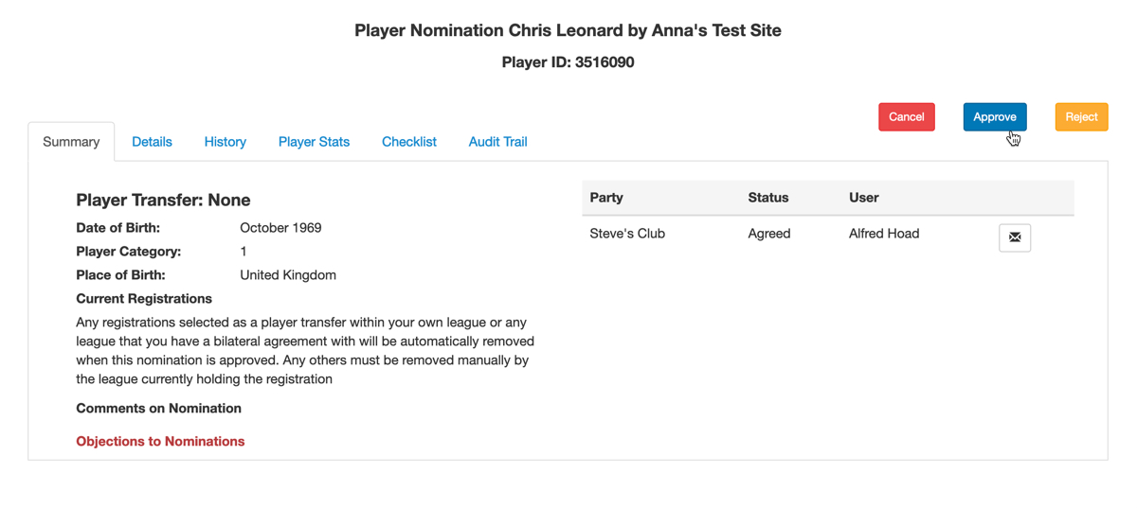

You can see that there are no objections to the nomination for league registration so the approval can take place.

When the registration process has completed, you are returned to the pending Player nominations screen.

In the following example, there is an objection by another league administrator:

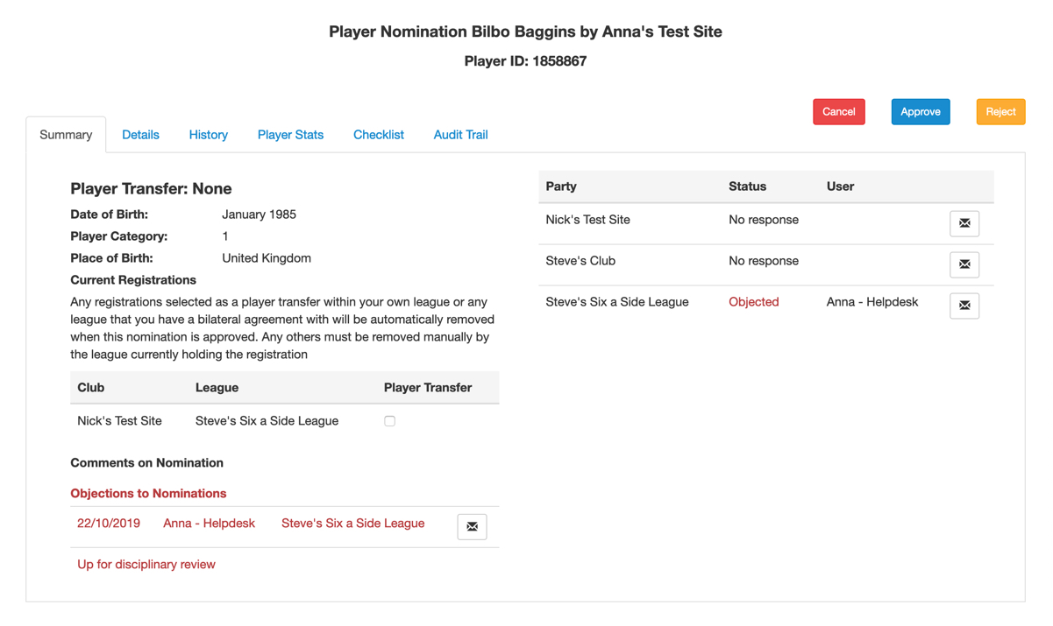
If you choose to reject the application, then a reason must be supplied.

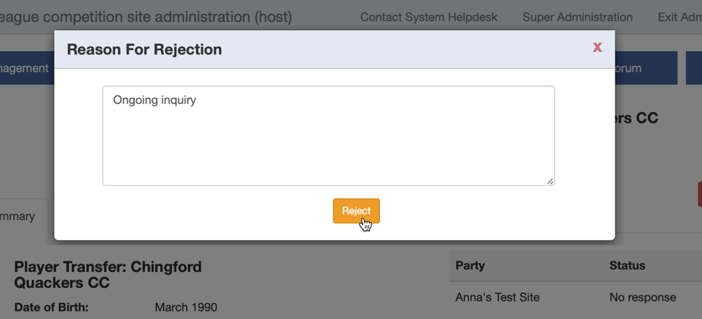

Player Transfers within your league

This screen shot shows that there is a player transfer to be processed.

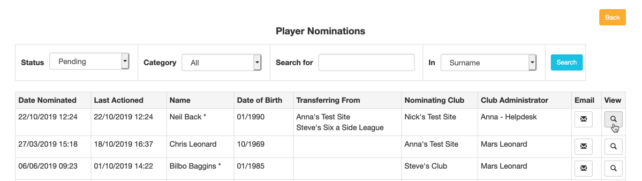

As before, if there is player matching, the details will be displayed for approval.

In this case, there are no records that require matching so the Player Transfer screen is displayed.

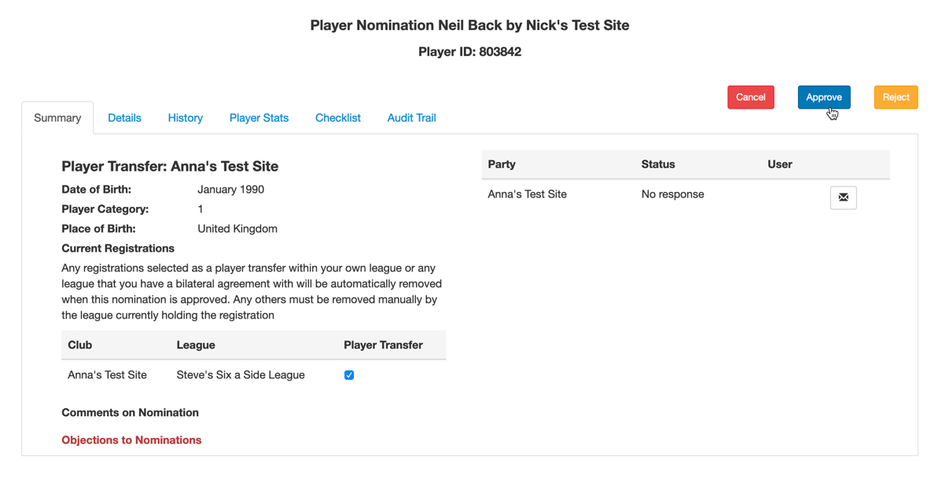

Note that the Date of Birth field displays only the month and year of birth.

If you untick the Player Transfer tick box both registrations will remain in place at the end of the process.

Use the tabs to find more information before deciding whether to approve or reject the nomination.

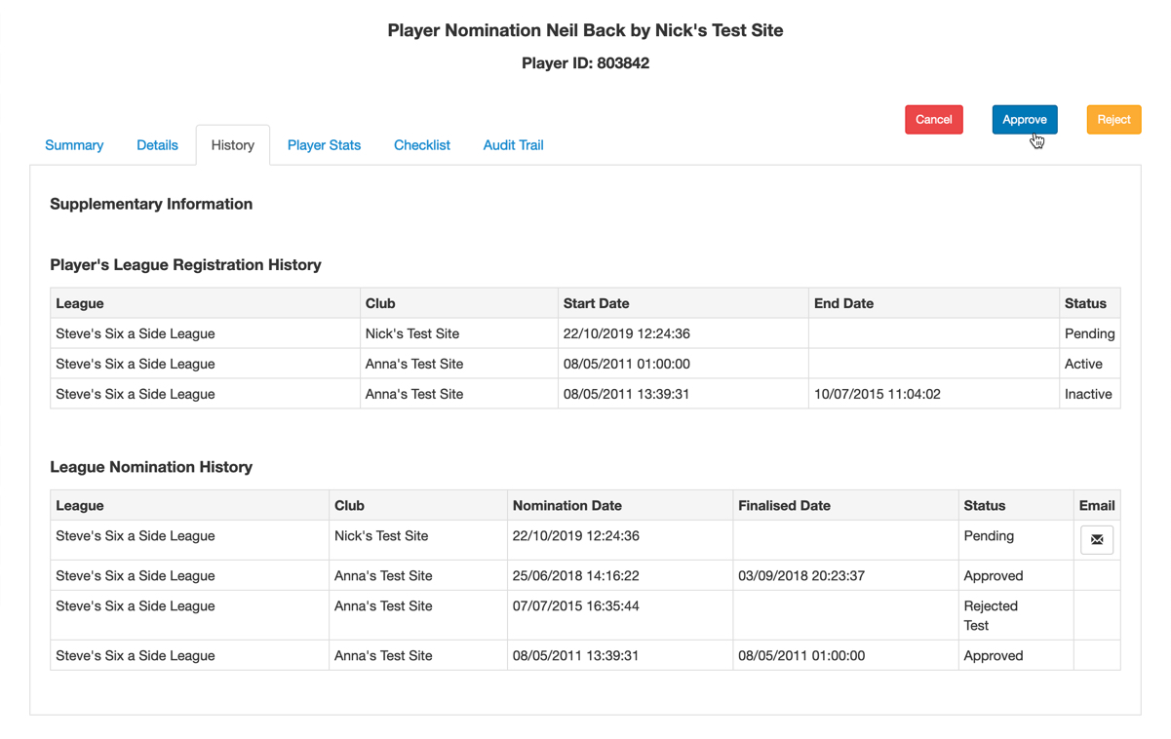
Following approval, the player’s registration with his previous club is made inactive unless you have de-selected the player transfer tick box.
The player’s details are ‘view’ only.

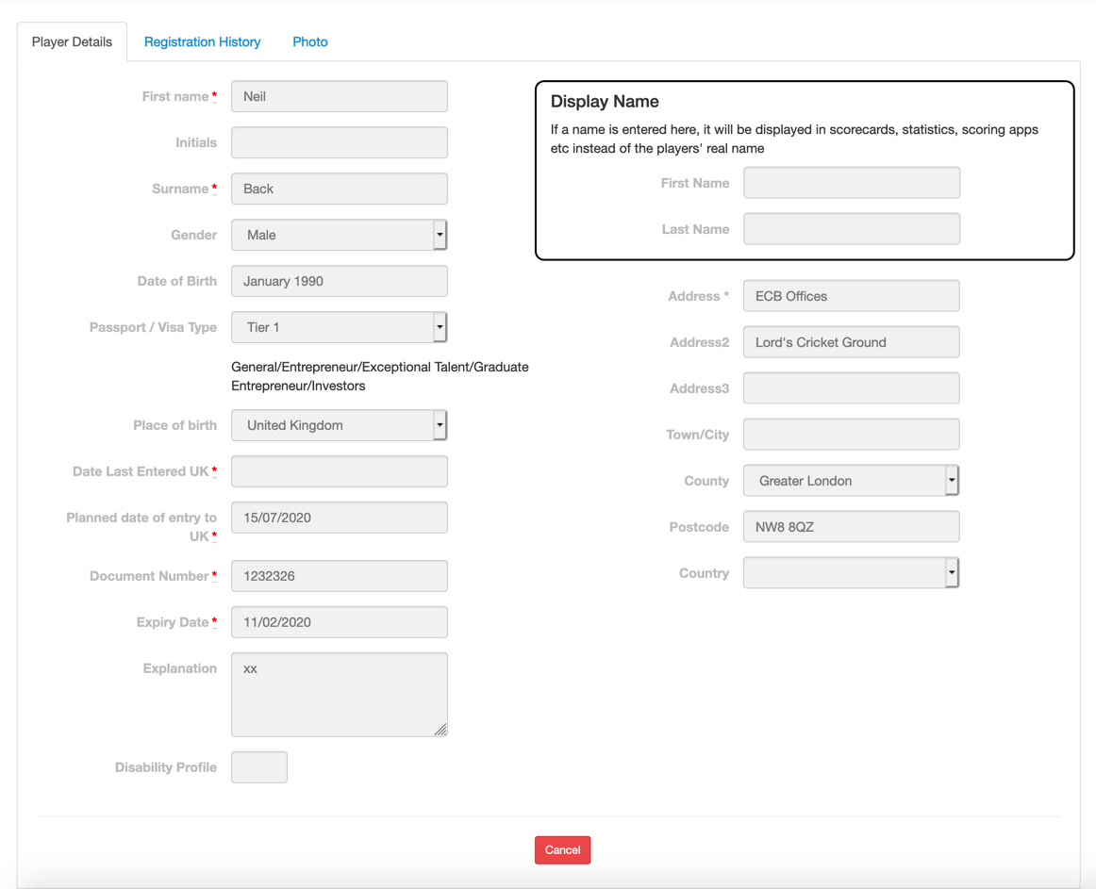

The player category may be changed via the Registration History tab if required.

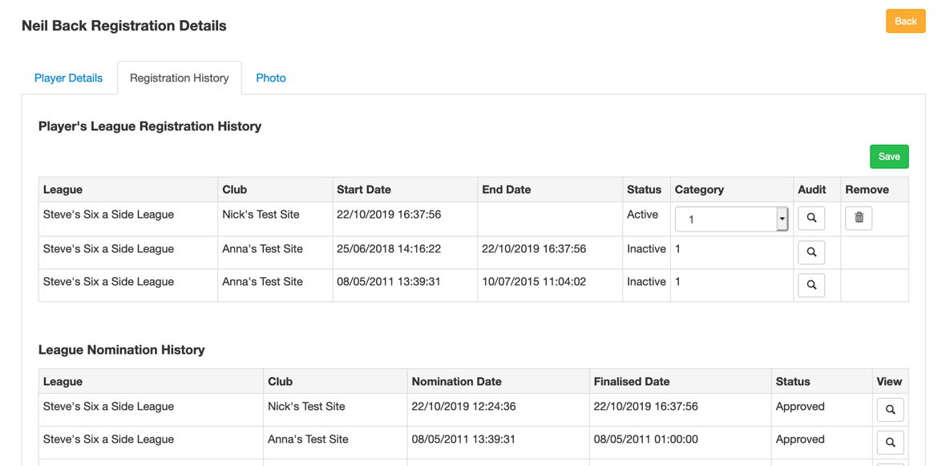

Player registration involving another league

In this example, a player has moved to a club in your league, but is still registered with his old club to a different league.
A notification would appear in the Admin home page of the league where the current registration is held as in the screen shot below.

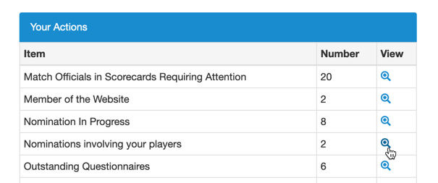

The league administrator will then be able to view the details

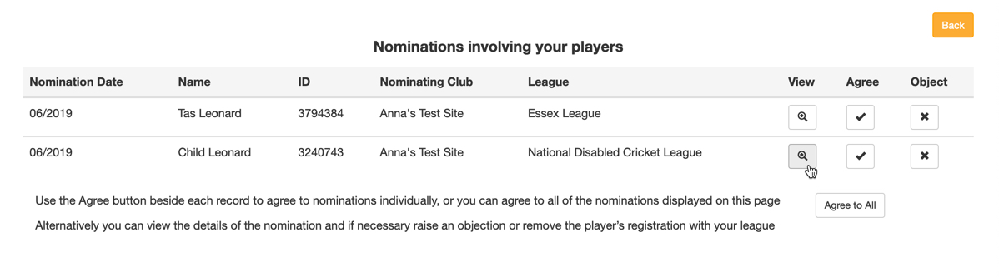

and agree or object to the nomination.

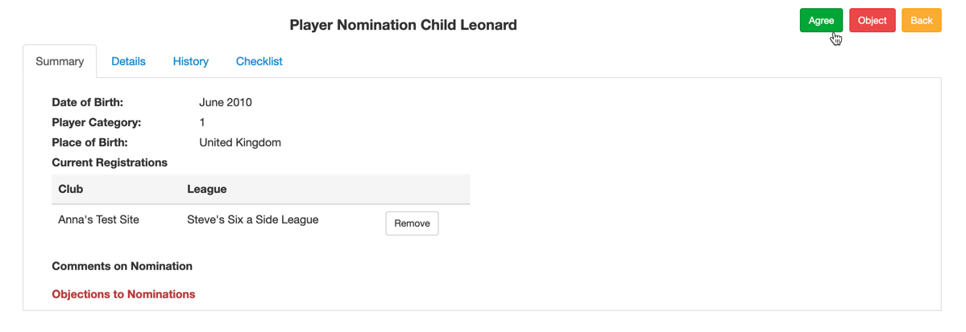
When you process the nomination, you may have one or more player records to match as before.

Continue to approve or reject the player matches until you get to the Player Nomination screen.
If you find an objection from the other league administrator, you have the option to email him to resolve the situation.
In this case, you could cancel the nomination and return to it later, or reject it entirely and ask the proposing club to re-submit the application.

Cancelling the player nomination does not cancel any player matching that has taken place, so this step will not have to be redone on subsequent nominations and all parties will then be able to see a complete set of roles and playing records to allow a better-informed decision on resubmitting the registration.

Players registered with other leagues notifications

You may see notification in the Admin Home page ‘Player registered with other leagues’.
This alert gives the league administrator a second opportunity to remove a player’s registration with their league or speak to the other league if they believe there is a problem.

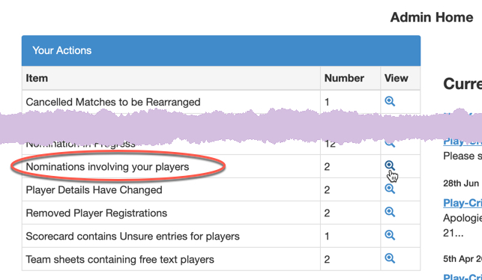

Click the view icon to see a list of registrations with other leagues that have not been acknowledged, involving players that have an active registration with that league, ordered chronologically by date with the latest at the top.

Up to 20 registrations will be displayed per page.

You may remove the registration from your own league, or acknowledge the player’s registration with both leagues.

There is an ‘Agree to All’ button at the bottom of the page, allowing you to acknowledge the registrations for a single page.

